COMP 353 Warm Up Project

Presented to :

Dr. Khaled Jababo

Presented by :

COMP 353_Group_8

|  |  |
| --- | --- |
| Jordan Hubscher | ID: 27019696 |
| Brandon Mendez | ID: 27003706 |
| Anthony Mendez | ID: 26998380 |

Entity Relationship Diagram

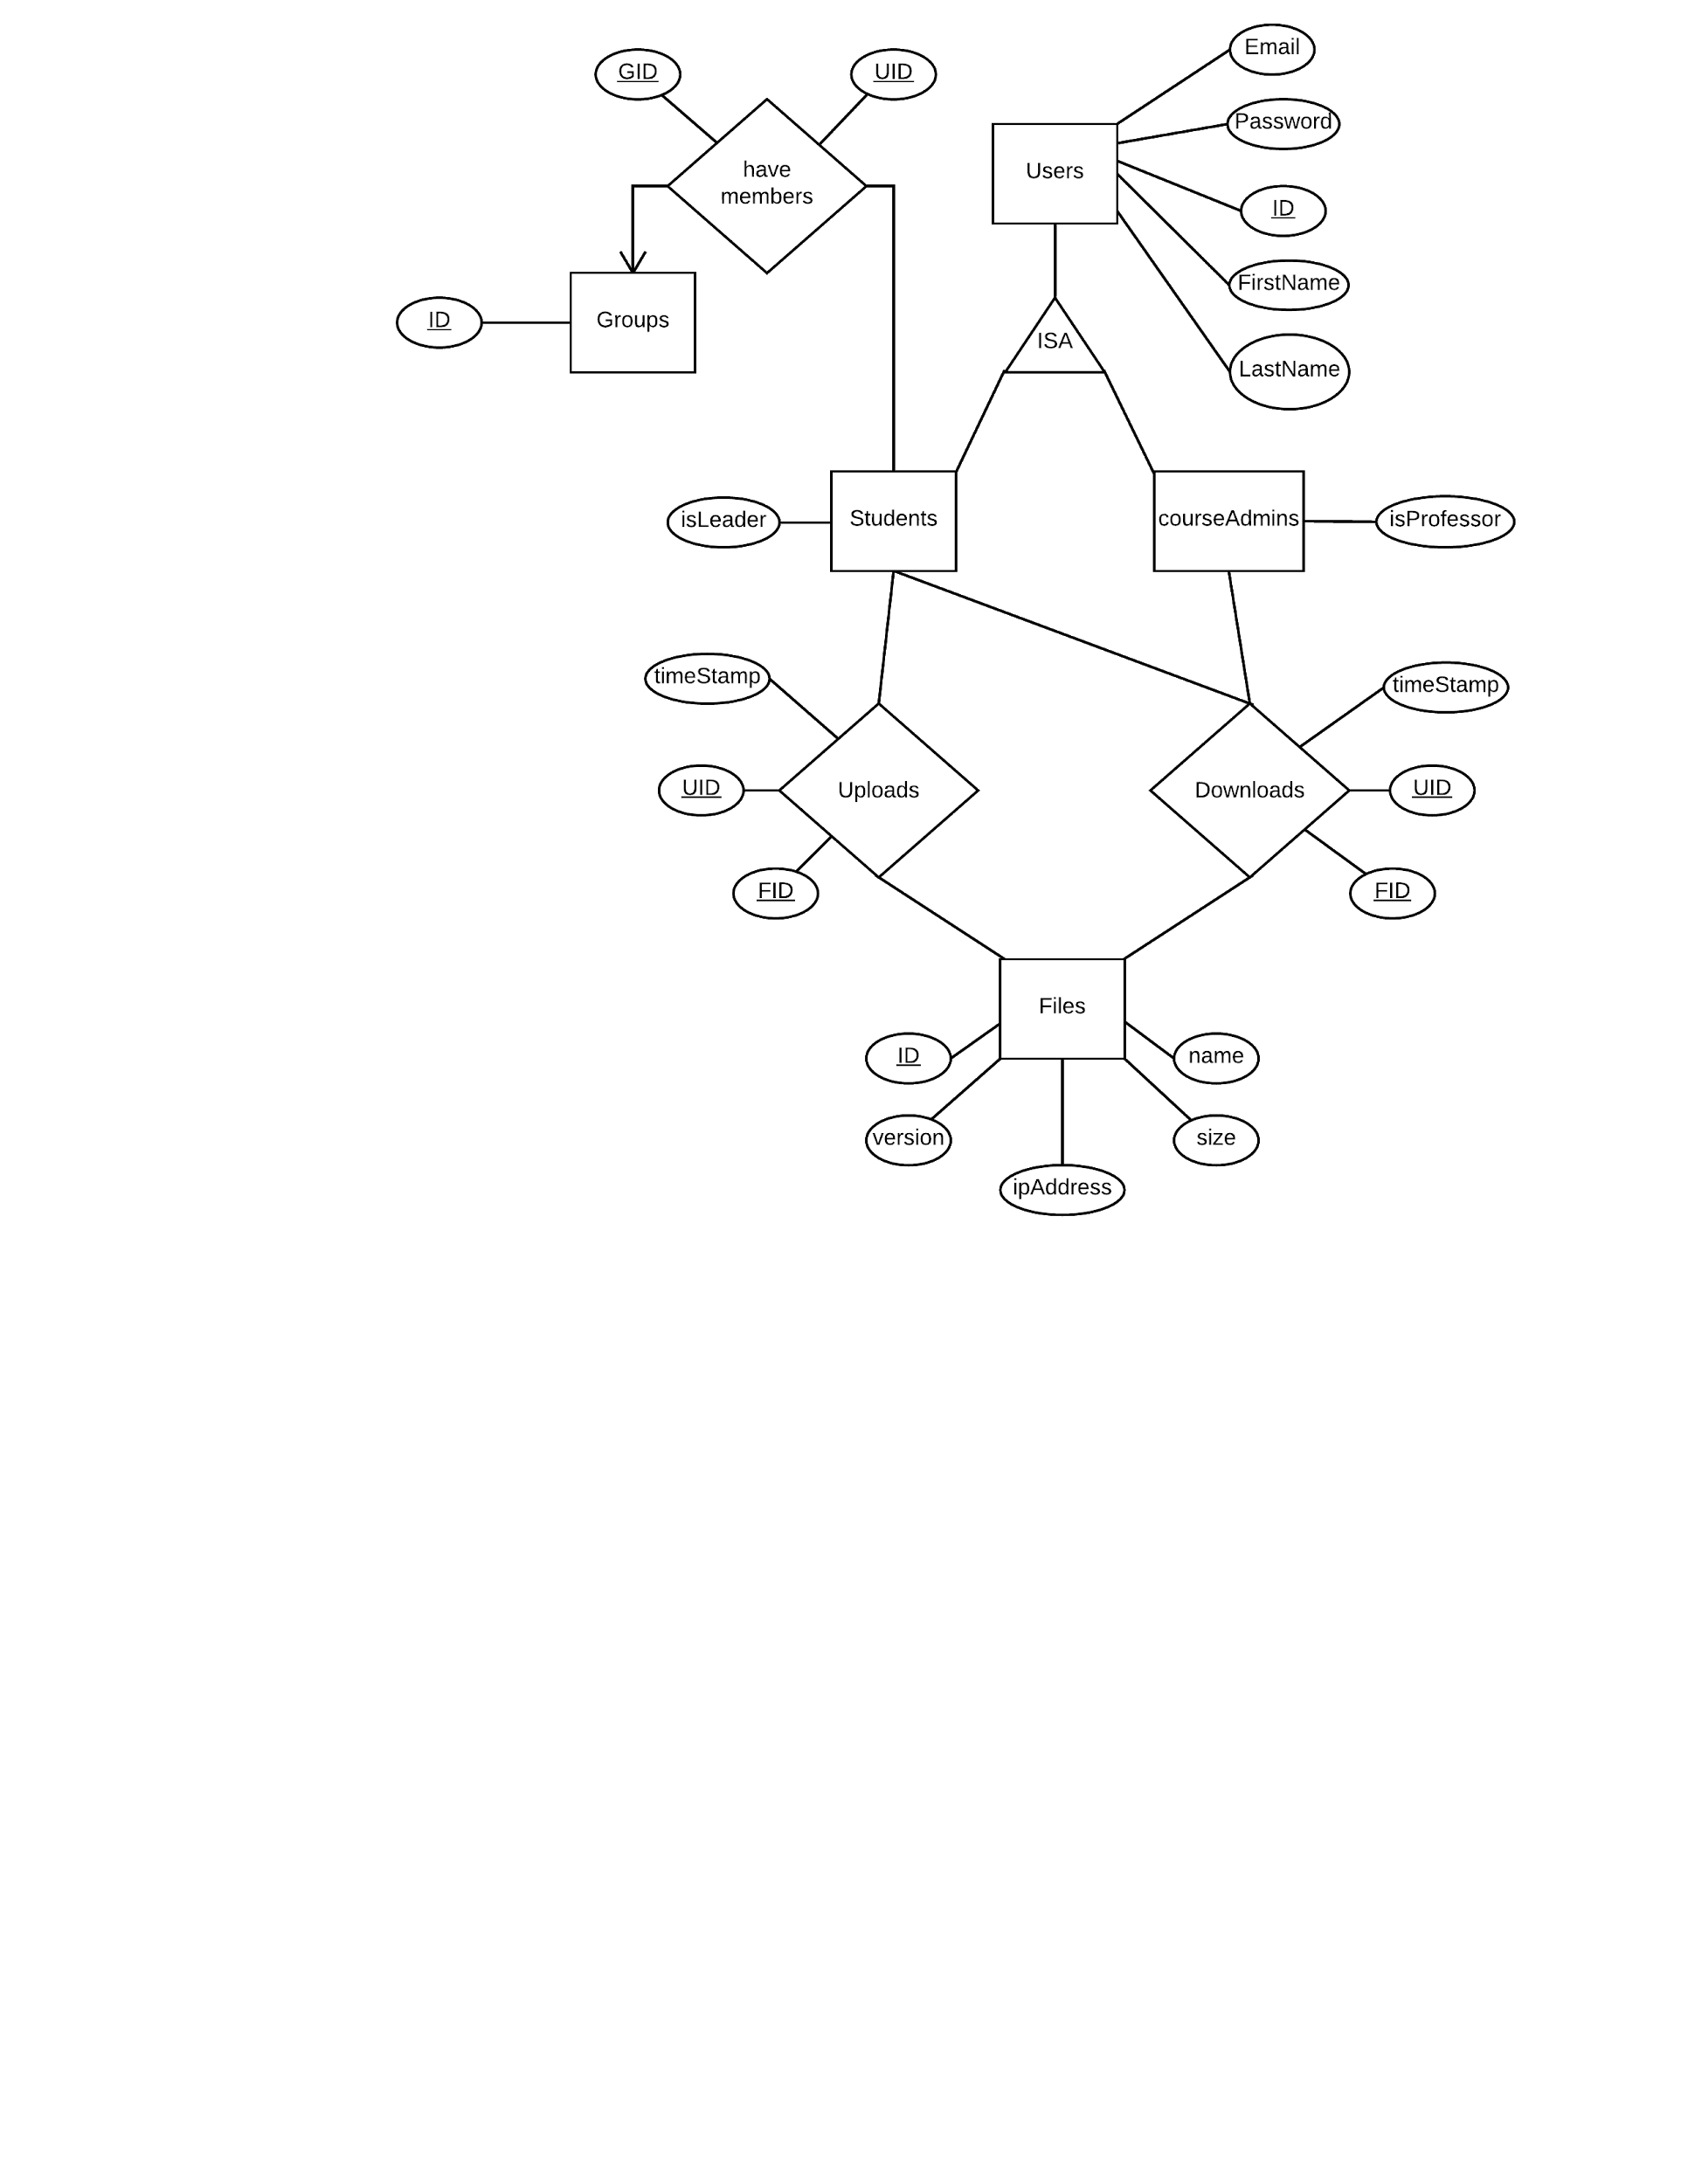

1. Show all of your tables

**SQL Query :** SHOW TABLES;

+----------------------------+

| Tables_in_comp353 |

+----------------------------+

| courseAdmins |

| downloads |

| files |

| groupMembers |

| groups |

| students |

| uploads |

| users |

+---------------------------+

2. List of all groups in the FSS.

**SQL Query :** SELECT * FROM groups;

+----+-------------------------------+

| id | name |

+----+-------------------------------+

| 1 | COMP 353_group_1 |

| 2 | COMP 353_group_2 |

| 3 | COMP 353_group_3 |

| 4 | COMP 353_group_4 |

| 5 | COMP 353_group_5 |

| 6 | COMP 353_group_6 |

| 7 | COMP 353_group_7 |

| 8 | COMP 353_group_8 |

| 9 | COMP 353_group_9 |

| 10 | COMP 353_group_10 |

| 11 | COMP 353_group_11 |

| 12 | COMP 353_group_12 |

| 13 | COMP 353_group_13 |

| 14 | COMP 353_group_14 |

+----+-------------------------------+

3. Provide details for a given group (group members and group leader).

* Details of Group 2 are displayed below

**SQL Query :** SELECT gid, id, isLeader, firstName, lastName, email FROM groupMembers JOIN (students JOIN users ON students.sid = users.id) ON groupMembers.sid = students.sid WHERE groupMembers.gid = 2;

+-----+----------+----------+-----------+------------+------------------------------------------------+

| gid | id | isLeader | firstName | lastName | email |

+-----+----------+----------+-----------+------------+------------------------------------------------+

| 2 | 26331602 | 0 | Daniel | Di Corpo | ddicorpo@gmail.com |

| 2 | 26650996 | 0 | Joseph | Atallah | joseph.atallah22@outlook.com |

| 2 | 29358269 | 1 | Dimitri | Topaloglou | dtopaloglou@gmail.com |

| 2 | 29439951 | 0 | Rahul | Malik | ra_malik@live.concordia.ca |

| 2 | 29773118 | 0 | Syrine | Krim | syrine_krim@hotmail.com |

+-----+----------+----------+-----------+------------+------------------------------------------------+

4. Provide details of all shared files for a given group (i.e. each project or assignment and the history for each file for each project or assignment).

* I’m pretty sure this is not applicable at this point in time [...]

5. Upload a given file by a given member.

**SQL Query :** SELECT id, firstName, lastName, name, timeStamp FROM users JOIN (uploads JOIN files ON uploads.fid = files.fid) ON users.id = uploads.sid;

+----------+-----------+------------+-------------+-------------------------------------------+

| id | firstName | lastName | name | timeStamp |

+----------+-----------+------------+-------------+-------------------------------------------+

| 29358269 | Dimitri | Topaloglou | upload1.txt | 2016-07-11 05:37:39 |

+----------+-----------+------------+-------------+-------------------------------------------+

6. Download a given file by a given member.

**SQL Query :** SELECT id, firstName, lastName, name, timeStamp FROM users JOIN (downloads JOIN files ON downloads.fid = files.fid) ON users.id = downloads.uid;

+----------+-----------+----------+-----------+----------------------------------------+

| id | firstName | lastName | name | timeStamp |

+----------+-----------+----------+-----------+----------------------------------------+

| 25609879 | Hussain | Qabbani | file1.txt | 2016-07-11 06:01:51 |

+----------+-----------+----------+-----------+----------------------------------------+